PRESENT SIMPLE
PRESENT CONTINUOUS
Training

Present tenses

Describe states
- I live with my parents
- They work for ABC Limited
- The Earth travels around the sun
- What do you do?
- Which team does he belong to?

Regular events
- I watch the news every morning.
- I go to Germany for Christmas
- How do you normally drive to work?

Thoughts / opinions
- He doesn’t like ice-cream
- I think you have got a cold
- I want a coffee.
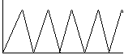
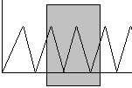

Describe a temporary state
- He can’t find the job he wants, so he is working at the shop.
- This week he is working on a special project.
- I am living with my parents until my house is decorated
- I am reading an interesting book at the moment.

To say what is happening at the moment
- I am studying English
- What are you doing?
- We’re having dinner
- Where are you going?

Future arrangements
- What are you doing tomorrow?
- I am playing tennis with John tomorrow at 5.00.
- He’s arriving next Tuesday at 3.00 pm
- Where are you going on holiday?

